**Name: Alpanshu Kataria**

**Reg. No. : 18BCE1267**

**Faculty: Maheshwari R**

**ECE-3502 IoT Domain Analyst LAB**

Lab 1

**Using appropriate nodes in node red, measure the light intensity in the room and output data to the web API. Display the output in Debug Monitor , UI, and send the data through MQTT and display the output in HiveMQ.**

**Flow:**

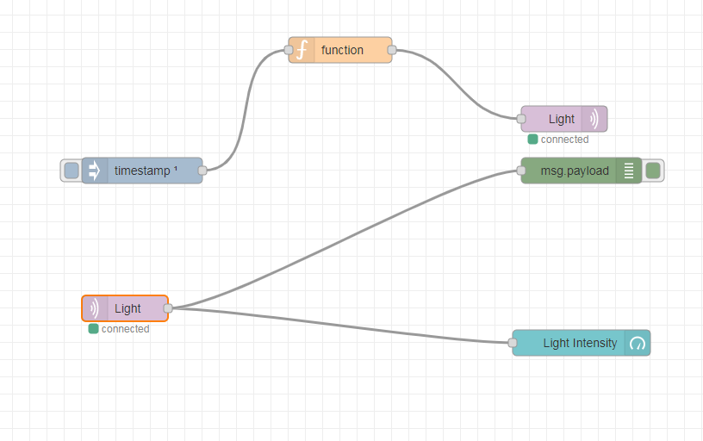

**Function Node:**

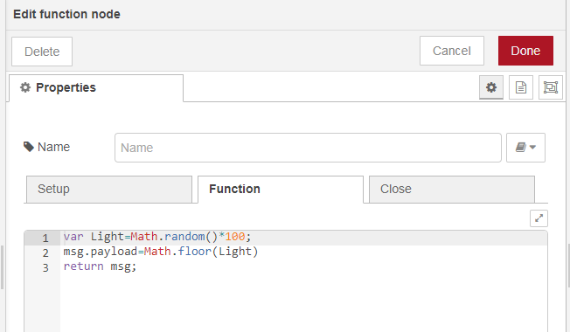

**MQTT Nodes:**

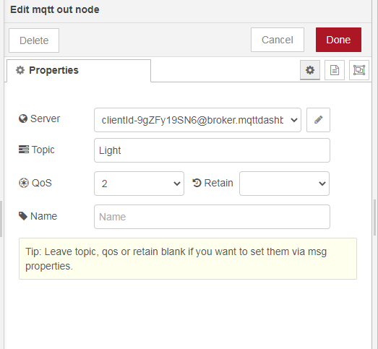

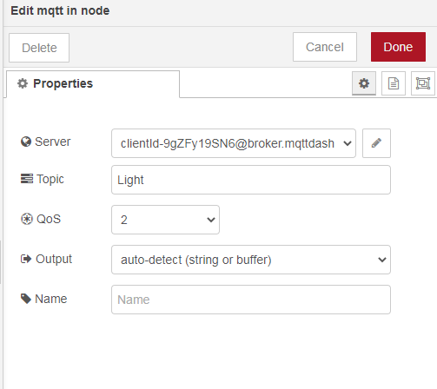

**Debug Monitor:**

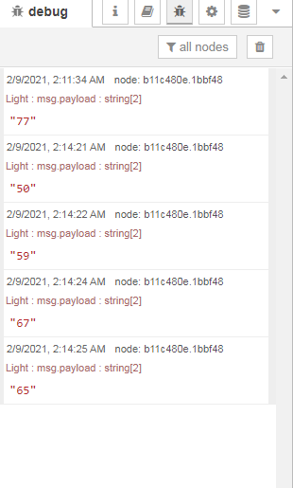

**UI:**

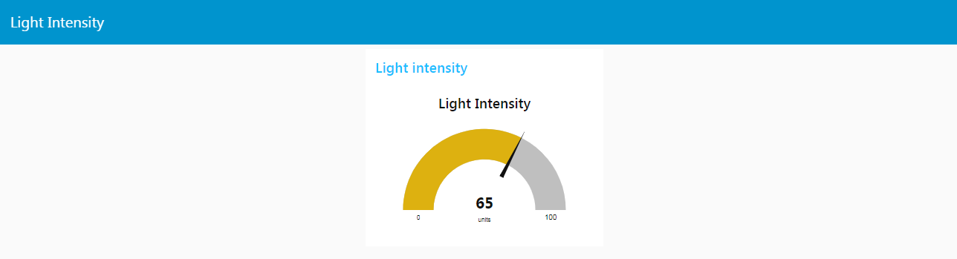

**Debug Window:**

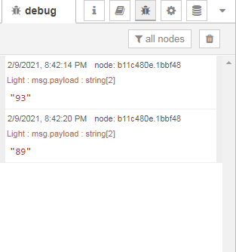

**Web UI:**

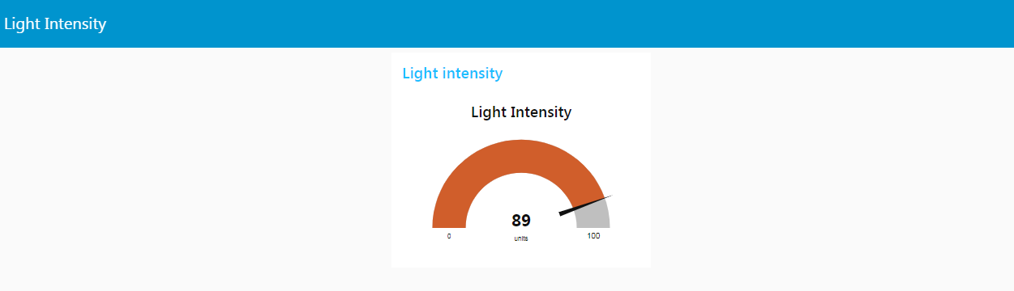

**Output in HiveMQ:**

